

Job Description and Person Specification

Job Title | Team Administrator
Directorate | Maternity and Newborn Safety Investigation (MNSI) programme
Department/Team | Business Services
Location | Home based
Grade | AfC Band 5
Reports to | Business Development manager
Contractual notes | Fixed term/secondment for 6 months with option to extend for further 6 months

Job Summary/Purpose
The Maternity and Newborn Safety Investigation (MNSI) programme, formerly the Healthcare Safety Investigation Branch (HSIB) maternity programme, moved to be hosted by the CQC on the 1 October 2023.

The maternity programme commenced under HSIB in April 2018, following the request from the then Secretary of State for Health and Social Care. The programme was part of the overall national maternity ambition to improve maternity safety and reduce harm by 50% by 2025. The programme was fully rolled out across England by April 2019. In 2026, a commitment was made to continue the programme until at least 2030.

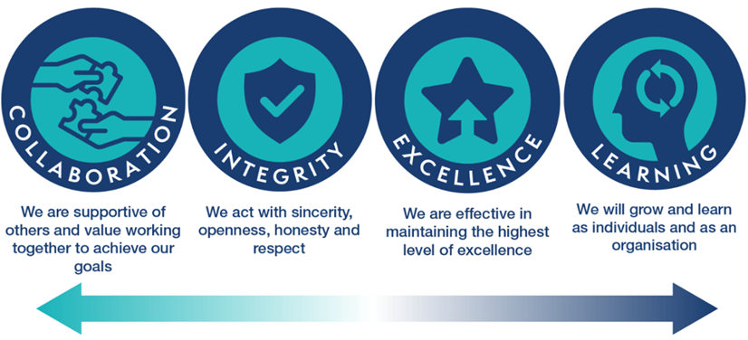
The purpose of the Team Administrator role is to provide efficient and effective administrative business support to the specified teams. This could include resolving day to day problems, diary management, organisation of meetings, managing communications, maintaining information or databases, producing agendas, minutes and actions of meetings, and other support activities.
Key Accountabilities
- Support the programme with administrative requirements
- Support the scheduling of relevant investigative meetings, i.e. clinical advisor panels
- Receive, examine, process and send documentation and correspondence on behalf of the team
- Triage content from calls and emails to ensure that relevant content is passed through as appropriate
- Provide administrative support for meetings as requested and to ensure follow up action(s) are completed. This can include setting up meetings, preparing agendas, producing notes of meetings and formal minutes of meetings and circulating to the appropriate parties.
- Arrange meetings, lunches and events, including finding venues, arranging catering and where required, transport etc
- Organise travel arrangements, including booking tickets and hotels, where required
- Set up and maintain manual and electronic files, as required, and ensure original documentation is retained or archived
- Create PowerPoint presentations
- Create and maintain entries within relevant databases
- General typing, photocopying, printing and scanning as required
- Ensure all relevant documents are uploaded to MNSI SharePoint pages
- On an ongoing basis, review the appropriate area on intranet to ensure documents remain up to date
- Monitor and ensure that all hardcopy documents no longer required are shredded or put in confidential waste bins
- Provide cover for other members of the admin team when they are on leave or when workload fluctuates, to ensure services are maintained
- Support the team with any ad hoc administrative requirements
- Propose and develop policies and procedures within own area to improve service
- Demonstrate competencies relevant to the role level and be a role model for MNSI’s values
- Support training programmes and learning events, including induction programmes.

Role Dimensions
Key Relationships (External)
- Department of Health / NHS England
- Suppliers (e.g. catering companies)
Key Relationships (Internal)
- Care Quality Commission (CQC)
- MNSI programme colleagues
- Business services team
Numbers and types of staff managed | Not applicable
Budget Managed | Not applicable

Person specification
Qualifications
Essential | Desirable
- Educated to a degree level in relevant discipline or equivalent level of demonstrable experience of working at a similar level
Experience & Knowledge
Essential | Desirable
- Experience of delivering an administrative role in a comparable organisation  - Knowledge of administrative processes and procedures  - Knowledge of a range of computerised software packages  - A flexible approach and readiness to work outside normal working hours if required  - Willingness to provide ad-hoc support to all team members, as and when necessary  - Sound communication skills  - Strong interpersonal skills, a team player and able to deal with stakeholders at all levels both internally and externally  - Strong organisational skills and an aptitude for forward planning, with an ability to prioritise  - Ability to undertake a diverse range of tasks at the same time  - Ability to maintain discretion and use initiative  - Good IT skills including use of Microsoft Office  - Ability to ensure accuracy, with good attention to detail | - Operational experience gained in the NHS or other healthcare system  - Knowledge & Experience of designing administrative processes and procedures.  - Experience of using MS SharePoint

Skills, Abilities and Attributes

Essential | Desirable
- Skills for communication on complex information and administrative matters, requiring developed interpersonal and oral/written communication skills  - Excellent time management skills with the ability to re-prioritise.  - Ability to work on own initiative and organise own workload with minimal supervision working to tight and often changing timescales. | - Problem solving  - UK Driving Licence

Values and behaviours
Essential | Desirable
- Commitment to and focused on quality, promotes high standards in all they do.
- Able to make a connection between their work and the benefit to patients and the public.
- Understands how the Equality Act 2010 affects the role and is proactive in delivering on this
- Values, upholds and promotes diversity and inclusion in interactions with patients, public and staff
- Ability to operate in a value-driven style consistent with the values of the public services and specifically with the new organisational values
- Works across boundaries, looks for collective success, listens, involves, respects and learns from the contribution of others
- Operates with integrity and openness
- Works well with others, is positive and helpful, listens, involves, respects and learns from the contribution of others.
- Consistently looks to improve what they do, look for successful tried and tested ways of working, and also seeks out innovation.
- Actively develops themselves and supports others to do the same.
- Needs to have a thorough understanding of and commitment to equality of opportunity and good working relationships both in terms of day-to-day working practices, but also in relation to management systems.
- Self-awareness in teams of emotional intelligence, biases and personal triggers with cultural sensitivity and awareness.
- Embraces change, viewing it as an opportunity to learn and develop.
- Demonstrates honesty and integrity and promotes organisational values.

